Value Investing in India: A Decade-Long Analysis of Benjamin Graham's Stock Selection Criteria

Introduction
Influenced by the timeless wisdom of Benjamin Graham, the "father of value investing," I became intrigued by the idea of identifying stocks that were fundamentally undervalued by the market. Graham's emphasis on margin of safety, rigorous financial analysis, and long-term perspective resonated with my inclination towards calculated and disciplined investment strategies. As the Indian stock market experienced rapid growth and increasing complexity, the question arose: Do the principles of value investing, forged in a different era, still hold relevance in today's dynamic market? This research endeavours to explore this question by examining the performance of a portfolio constructed based on Graham's criteria against the benchmark Nifty 50 index. By delving into the historical data and employing quantitative analysis, I aim to shed light on the enduring power of value investing and its potential to generate superior returns in the Indian context.
Objective
The primary objective of this research is to identify and analyse stock selection criteria inspired by Ben Graham's value investing principles. By applying Graham's methodologies, I aim to uncover whether these time-tested criteria still hold relevance and can be effectively used to select undervalued stocks in today's market.
The primary objective of this study is to assess the continued relevance of Ben Graham’s stock selection criteria in today’s financial markets. Specifically, the study aims to:
- Evaluate Historical Performance: Analyse how stocks selected based on Graham’s criteria (low P/E ratio, low P/B ratio, and high dividend yield) have performed over the past decade compared to the Nifty 50 index.
- Assess Relevance: Determine if these value investing criteria still serve as effective indicators of stock performance in the modern market environment.
- Provide Insights: Offer insights into the effectiveness of these criteria and their applicability to contemporary investment strategies.

Data Collection
The key financial metrics used for stock selection include the Price-to-Earnings (P/E) ratio, Price-to-Book (P/B) ratio, and Dividend Yield. The data for this analysis is sourced from the following platforms:
- Yahoo Finance: Provides historical stock prices and financial metrics. The URL for accessing this data is: Yahoo Finance.
- Money control: Offers detailed financial data, including historical P/E ratios, P/B ratios, and Dividend Yields for Nifty 50 companies. The URL for accessing this data is: Moneycontrol.
- National Stock Exchange (NSE) of India: Provides historical data on the constituents of the Nifty 50 index, including details on the stocks that have been part of the index over time. The URL for accessing this data is: NSE Indices.

Quantitative Tools Selected and the Reason for Doing So
To achieve the study’s objectives, the following quantitative tools and methods are employed:
- Descriptive Statistics: To summarize key characteristics of the data, including mean returns, beta, standard deviation, and cumulative returns of selected stocks and the Nifty 50 index.
  - Reason: Provides a foundational understanding of performance and risk.
- Ranking and Selection Analysis: To rank stocks based on P/E ratio, P/B ratio, and dividend yield, and to select the top 15 based on these criteria.
  - Reason: Allows identification of stocks that meet Graham’s criteria for further analysis.
- Performance Comparison: To compare the performance of selected stocks against the Nifty 50 index using metrics such as total return and annualized return.
  - Reason: Assesses the effectiveness of Graham’s criteria in generating returns relative to a benchmark.
- Visualization Tools: To present findings through graphical representations such as line chart and bar chart.
  - Reason: Facilitates clear communication of trends and comparative results.

Data Analysis and Interpretation
Data Overview
The analysis spans from April 1, 2014, to March 31, 2024. The portfolio is evaluated annually on April 1st, with returns calculated based on this date each year. The Nifty 50 index serves as the benchmark for comparison. The portfolio selection criteria, inspired by Ben Graham's value investing principles, were applied annually to identify stocks that met the specified metrics.
Portfolio Performance
- Annual Returns: The portfolio's performance was tracked over 10 years, with annual returns calculated for each year.
- Comparison with Nifty 50: Similarly, the Nifty 50 index's annual returns were recorded for the same period.
Key Findings
- Outperformance: The portfolio outperformed the Nifty 50 index in 7 out of the 10 years.
- Compound Annual Growth Rate (CAGR):
  - Portfolio: 19.72%
  - Nifty 50 Index: 11.81%

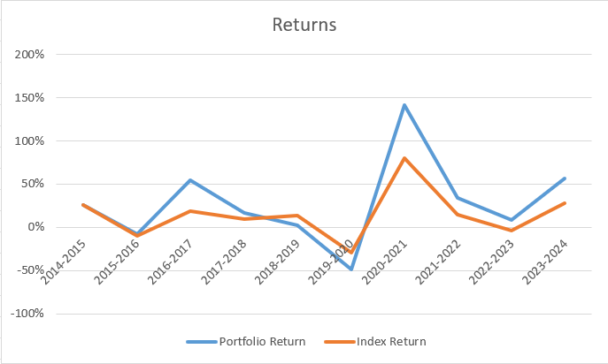

The higher CAGR of the portfolio indicates a superior growth rate compared to the market index over the 10-year period.
- Beta: The beta of the portfolio was calculated to be around 0.85.
  - Significance of Beta:
    - A beta of 0.85 suggests that the portfolio is less volatile than the market. Specifically, the portfolio's returns are expected to move 15% less than the market returns. This implies lower risk compared to the broader market.

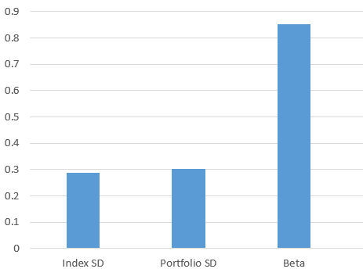
- Standard Deviation:
  - Nifty 50 Index: 0.28
  - Portfolio: 0.30
The standard deviation measures the dispersion of returns from the mean. A higher standard deviation indicates greater volatility. The portfolio's standard deviation is slightly higher than that of the Nifty 50 index, suggesting marginally higher volatility.

Conclusion
The analysis demonstrates that the stock selection criteria inspired by Ben Graham's value investing principles have been effective over the 10-year period. The portfolio not only achieved a higher CAGR than the Nifty 50 index but also managed to outperform the market in 7 out of 10 years. The portfolio's beta of 0.85 indicates lower volatility compared to the market, which is favourable for risk-averse investors. Despite a slightly higher standard deviation, the overall risk-adjusted performance of the portfolio is commendable.
The evidence presented in this research strongly supports the continued relevance of Ben Graham's value investing principles in the Indian market. While the market has evolved, the core concept of identifying undervalued stocks based on fundamental analysis remains a viable investment strategy.

References
  - Ben Graham's Net Current Asset Values: A Performance Update Author(s): Henry R. Oppenheimer. Source: Financial Analysts Journal, Vol. 42, No. 6 (Nov. - Dec., 1986), pp. 40-47
  - Explaining the Recent Failure of Value Investing Baruch Lev and Anup Srivastava.
  - Efficient Capital Markets: II Eugene Fama Source: The Journal of Finance, Vol XLVI, No. 5 (December 1991)

